TOP SCORER DATA IN MAJOR FOOTBALL LEAGUES 2016-2020 ANALYSIS

- DESCRIPTION OF RAW DATA
- Number of rows: 660
- Number of columns: 18
- Performance Metrics:
- Matches Played
- Substitution
- Mins
- Goals
- xG
- xG Per Avg Match
- Shots
- OnTarget
- Shots Per Avg Match
- On Target Per Avg Match
- MPG
- xG Performance
- Weighted Goals

- Identifiers:
- Country
- League
- Club
- Player Name
- Year
- Candidate Target Variables:
- Goals
- xG
- xG Performance
- Weighted Goals
- MPG

- DATA EXPLORATION PLAN

We aim to answer questions such as:
    - Who are the most efficient scorers?
    - Which leagues have higher scoring output?
    - How does playing time affect scoring efficiency?
    - Is there a relation between volume and efficiency?
    - Do leagues affect scoring efficiency?

- EDA
First, we get some information about our data.

Variable | Count | Mean | Std Dev | Min | 25% | 50% (Median) | 75% | Max
Matches_Played | 660 | 22.37 | 9.75 | 2.00 | 14.00 | 24.00 | 31.00 | 38.00
Substitution | 660 | 3.22 | 3.84 | 0.00 | 0.00 | 2.00 | 5.00 | 26.00
Mins | 660 | 2071.42 | 900.60 | 264.00 | 1363.50 | 2245.50 | 2822.00 | 4177.00
Goals | 660 | 11.78 | 5.98 | 2.00 | 8.00 | 11.00 | 14.00 | 37.00
xG | 660 | 10.09 | 5.72 | 0.71 | 6.10 | 9.29 | 13.25 | 32.54
xG Per Avg Match | 660 | 0.48 | 0.19 | 0.07 | 0.34 | 0.44 | 0.57 | 1.35
Shots | 660 | 64.18 | 34.94 | 5.00 | 37.75 | 62.00 | 86.00 | 208.00
OnTarget | 660 | 28.37 | 16.36 | 2.00 | 17.00 | 26.00 | 37.00 | 102.00
Shots Per Avg Match | 660 | 2.95 | 0.91 | 0.80 | 2.34 | 2.85 | 3.38 | 7.20
On Target Per Avg Match | 660 | 1.32 | 0.47 | 0.24 | 0.98 | 1.25 | 1.54 | 3.63
Year | 660 | 2018.36 | 1.37 | 2016.00 | 2017.00 | 2019.00 | 2019.00 | 2020.00
MPG | 660 | 185.64 | 61.58 | 49.63 | 141.31 | 181.14 | 224.71 | 435.57
xG Performance | 660 | 1.28 | 0.42 | 0.56 | 1.01 | 1.20 | 1.43 | 5.63
Weighted Goals | 660 | 10.96 | 6.10 | 1.50 | 6.75 | 10.00 | 14.00 | 37.00

Important Takeaways are:
- The mean xG Performance is 1.28, which suggests that most players score above their expected goals
- The average number of goals per season for a player is around 12, while the max is 37 which is a far outlier
- On average, players shoot around 40% of their shots on target.
- Substitute appearances vary widely, as the stdev. is even bigger than the mean.
Below are 2 line plots, comparing top 10 scorers per year by goals scored and games played.

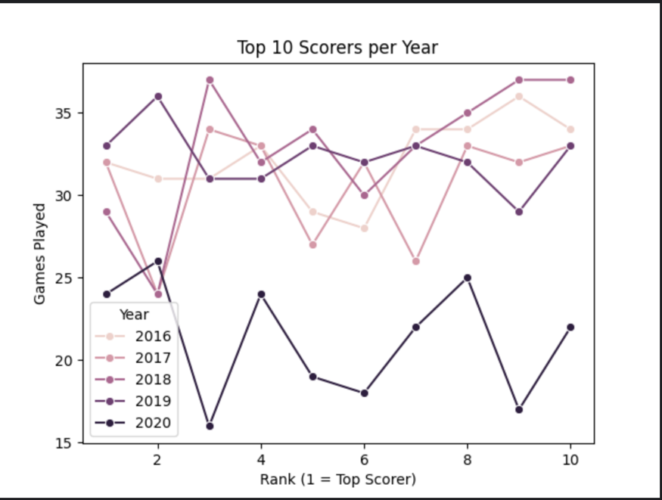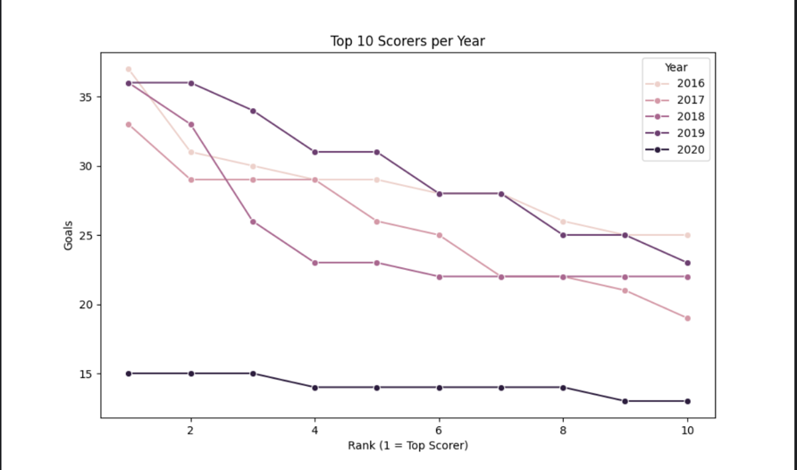

2020 sees a drop in both goals and appearances, which suggests they’re related especially due to covid in that year.

We also notice that towards the tail of the scorers table the difference between players tends to become smaller, as more players are able to hit 20 goals rather than 35+.

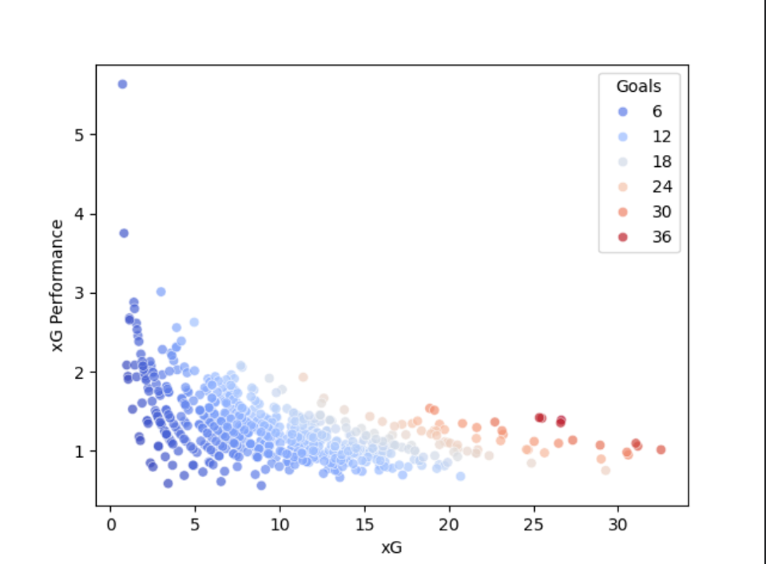

Above is a scatter plot comparing xG to xG Performance, where the hue indicates how many goals a player scored.

As we can see, the outliers exist where the volume is low, as they didn’t take enough shots for the sample to be sufficient, however as the xG increases the points come closer and closer between 1-2 especially around 1.25-1.5.

